Amazon E-Commerce Project Documentation

Observations and insights for Objective and Subjective questions:

Objective Questions:
- What is the total number of attributes in the customer table?

- The total number of attributes in the customers table is the number of columns it has.
- The customers table has 3 attributes i.e. (CustomerID, Customer Age, Customer Gender)
- How will you get the “Customer’s” ages in the “Order” tables according to customer IDs?

- To get the Customer’s Ages in the Orders table according to Customer IDs, you need to establish a relationship between the customers table and the orders table, then create a calculated column or use the related field in your visuals.
- Establish a Relationship Between Tables by Drag and drop CustomerID from the customers table onto CustomerID in the orders table.
- We can now use the Customer Age field in the customers table to interact with the orders table by creating a calculated column using a DAX formula.
- Customers Age = LOOKUPVALUE(Customers[Customer Age],Customers[CustomerID],Orders[CustomerID]

- In analyzing the dataset with Power BI, ensure data cleaning to address inconsistencies and missing values before further analysis.

- By the use of Power Query Editor, I clean the data for better analysis. First, I transform the data into power query editor and start cleaning the data.
- In data cleaning, I make sure that all the columns do not have any empty rows. After removing the empty rows, I changed the data type of order date and delivery date column to “Date” type.
- In the reason column, there were some empty rows without any reason for return of the product and for delivered products. So, I replaced those rows “Not Applicable” reason for empty rows whose products were delivered.
- By looking at the data set, there were 5 extra columns which are not necessary, so I removed them from the data set.

- How can we calculate the total revenue generated by all the sales?

- To calculate the Total Revenue, I created a New Measure in Power BI using the SUM() DAX function.
This measure helps calculate the overall revenue generated from all the sales recorded in the dataset. First I move to Report View and To calculate the Total Revenue, I have created a New Measure to sum the Sale Price Column. The DAX formula is Total Revenue = SUM(Orders[Sale Price]) which gives the answer Total Revenue of 107.23M.

Steps Performed:
- In Power BI Desktop, I selected the Orders table in the Data pane.
- Then, on the top ribbon, I went to Modeling → New Measure.
- In the formula bar, I entered the following DAX formula: Total Revenue = SUM(Orders[Sale Price])
- After pressing Enter, the new measure appeared under the Orders table with a calculator icon.
- I then added a Card visual in the report canvas and dragged the Total Revenue measure into the Values field to display the result.
- Finally, I formatted it as Currency (₹ or $) under Measure Tools.
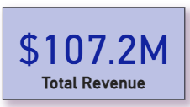
- What is the total number of unique customers who made purchases each year? Is there any increase in the number over the years?

- The analysis of unique customers by year shows a relatively stable customer base between 2015 – 2019, with yearly unique customers remaining around 17K – 17.7K. However, there is a significant increase in 2020, where the number of unique customers sharply rises to approximately 25.2K, representing a strong growth in new or returning customers.
- This upward trend indicates that the company successfully expanded its customer base in 2020 — possibly due to improved marketing efforts, increased online reach, or enhanced product offerings. It suggests growing brand awareness and higher customer acquisition, a positive indicator for business performance and market penetration.
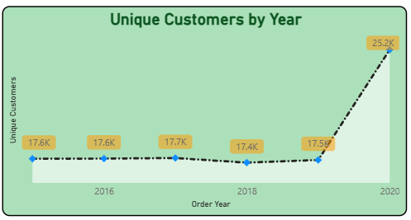
- How can we determine the total number of unique products available in the company?

- To determine the total number of unique products available in the company, I created a new DAX measure using the DISTINCTCOUNT function: Unique Products = DISTINCTCOUNT(Orders[Product])
- The result returned a total of 45 unique products, representing the complete range of items listed in the company’s e-commerce catalogue.
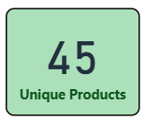
- What is the average number of days it takes for products to be delivered, get the metric for only the delivered orders.

- To calculate the average number of days taken for delivery, I first created a calculated column using the DAX formula:
Delivery Days = DATEDIFF(Orders[OrderDate], Orders[Delivery Date], DAY)
- Then, I created a measure to find the average delivery duration only for delivered orders:
Avg Delivery Days = CALCULATE(AVERAGE(Orders[Delivery Days]), Orders[Status] = "Delivered")
- This measure returned an average delivery time of 9.41 days, indicating the typical time required to complete successful deliveries.
- By using the card visual, I presented the Avg Delivery Time for Delivered orders, inserting the calculated column Avg Delivery Time for Delivered Orders.
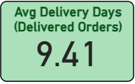
- Which products, categories, and subcategories are the most popular?

- Based on my analysis: Health and beauty, Fashion, and Electronics are the 3 most popular product categories.
- I’ve added a Table visual showing Product Category, Sub-Category, Product, and Units Sold.
- Created DAX measures:
Units Sold = SUM(Orders[Order Quantity])
Total Revenue = SUM(Orders[Sale Price])
- Applied a Top N Filter (Top 5) on the Product field using the Units Sold measure to highlight the most popular products.
- Added Slicers for Product Category, Delivery Type, Age, and Gender to enable interactive filtering.
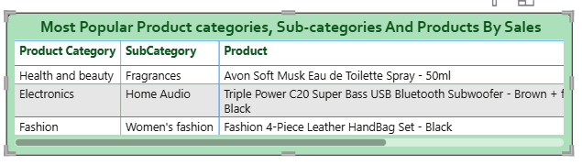
- Which products have seen an increase or decrease in sales over the year?
Steps & Implementation:
- Added a Year slicer using the Order Year field to filter the dataset by year.
- Created a Bar Chart visual showing Product on the Y-axis and [Total Revenue] on the X-axis.
- Used the Total Revenue measure (SUM(Orders[Sale Price])) to evaluate annual product performance.
- Enabled interactive filtering: changing the year updates the chart, allowing year-to-year comparison.
Insight:
- The visual highlights how product revenue shifts across years.
- Stakeholders can easily spot products whose sales increased or declined by switching between years using the slicer.
- This helps identify trends and decide which products need marketing focus or stock adjustments.
- While modeling the data relationships, what will be the type of relationship between the customer ID of Orders and customer tables?

- The type of relationship between the CustomerID in the orders table and the customers table in data modeling will be a Many-to-One relationship.
- Each order in the orders table is associated with exactly one customer in the
- customers table via CustomerID.
- Multiple orders in the orders table can belong to the same CustomerID, but each CustomerID in the customers table is unique.
- Many rows in the orders table are associated with one row in the customers table.
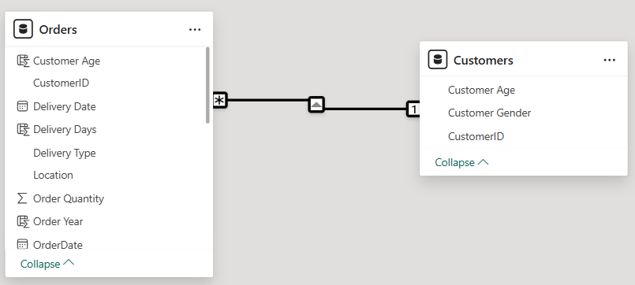
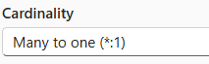
- When analyzing from the Orders table, each record (order) belongs to a single customer. This creates a Many-to-One mapping from orders to customers.
- How have you handled the null values in the data?
Steps & Implementation:
- Opened all tables in Power Query to inspect for missing or null values.
- Used filters on columns to detect blanks and null entries.
- Removed 199 completely blank rows from the Orders table using Home → Remove Rows → Remove Blank Rows.
- For the Reason column: Replaced blanks for delivered products with “Not Applicable”.
- In the Product Category column, filled the single null value with the correct category by replace values.
- Applied Replace Values and Trim/Clean transformations to remove hidden spaces and standardise text fields.
- Verified after cleanup that no slicers or visuals displayed “(Blank)” values.
- Were there any data format issues in the data, and if there were/are how you would handle them?
Steps & Implementation:
- While importing data from Excel into Power BI, identified inconsistent data formats in several columns (e.g., Date, Numeric, and Text fields).
- In Power Query, verified and corrected data types for each column:
- OrderDate and Delivery Date → changed to Date type.
- Sale Price, Order Quantity, and Shipping Charges → changed to Decimal Number / Whole Number type.
- Product Category, SubCategory, and Customer Name → set to Text type.
- Used Transform → Detect Data Type and Change Type → Using Locale for any regional date mismatches.
- Applied Trim and Clean functions to text columns to remove extra spaces and invisible characters that caused formatting inconsistencies.
- Ensured consistent formats so DAX measures (like SUM, AVERAGE, and DATEDIFF) worked correctly without errors.
- Revalidated visuals and slicers after transformations to confirm data types and formatting were correct.
Result:
- Eliminated all data format mismatches across tables.
- Prevented aggregation errors and ensured accurate data modeling and analysis in Power BI.
- When we add a column in Power Query what’s the code that comes in M language in the formula bar? What do you know about M-query?
Steps & Explanation:
- Every transformation performed in Power Query (like adding columns, removing rows, changing types, etc.) is written automatically in a language called M (M-Query).
- When you add a new column, Power Query generates an M-language expression in the formula bar.
- Example: = Table.AddColumn(#"Previous Step", "New Column", each [Sale Price] * [Order Quantity])
- This code tells Power BI to add a new column named “New Column” which multiplies Sale Price by Order Quantity for each row.
- Each transformation step you perform in Power Query (like Replace Values, Remove Rows, etc.) is saved sequentially as an M-Query step in the Applied Steps pane.
- You can view or edit all these steps using the Advanced Editor in Power Query.
About M-Query:
- M-Query is a functional language used in Power Query to load, clean, and transform data before it reaches Power BI’s data model.
- It is case-sensitive and reads transformations from top to bottom.
- It works differently from DAX — M is for data shaping and transformation (before loading), while DAX is for data calculation and modeling (after loading).
- Identify the top 5 most valuable customers using a composite score that combines three key metrics: (SQL)
  - Total Revenue (50% weight): The total amount of money spent by the customer.
  - Order Frequency (30% weight): The number of orders placed by the customer, indicating their loyalty and engagement.
  - Average Order Value (20% weight): The average value of each order placed by the customer, reflecting the typical transaction size.
Query:
WITH CustomerMetrics AS (
SELECT
o.CustomerID,
SUM(o.SalePrice) AS TotalRevenue,
COUNT(o.OrderID) AS OrderFrequency,
AVG(o.SalePrice) AS AvgOrderValue
FROM
orders o
GROUP BY
o.CustomerID
),
NormalizedMetrics AS (
SELECT
cm.CustomerID,
cm.TotalRevenue,
cm.OrderFrequency,
cm.AvgOrderValue,
cm.TotalRevenue / (SELECT MAX(TotalRevenue) FROM CustomerMetrics) AS NormalizedRevenue,
cm.OrderFrequency / (SELECT MAX(OrderFrequency) FROM CustomerMetrics) AS NormalizedFrequency,
cm.AvgOrderValue / (SELECT MAX(AvgOrderValue) FROM CustomerMetrics) AS NormalizedValue
FROM
CustomerMetrics cm
),
CompositeScores AS (
SELECT
nm.CustomerID,
(nm.NormalizedRevenue * 0.50) +
(nm.NormalizedFrequency * 0.30) +
(nm.NormalizedValue * 0.20) AS CompositeScore
FROM
NormalizedMetrics nm
)
SELECT
cs.CustomerID,
cs.CompositeScore
FROM
CompositeScores cs
ORDER BY
cs.CompositeScore DESC
LIMIT 5;

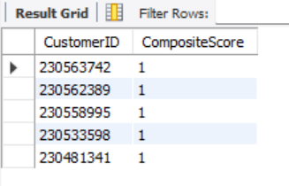

Insights:
- The top 5 customers achieved a composite score 1, indicating consistently high performance across all metrics.
- These customers represent a highly engaged and profitable segment, ideal for loyalty programs, personalised offers, or premium memberships.

Business Recommendation:
Focus on customer retention strategies for these high-value customers by offering:
- Exclusive deals or early access to sales,
- Loyalty points or membership tiers, and
- Personalised communication to strengthen brand loyalty.

- Calculate the month-over-month growth rate in total revenue across the entire dataset. (SQL)
Query:
WITH MonthlyRevenue AS (
SELECT
DATE_FORMAT(str_to_date(OrderDate,'%d/%m/%Y'), '%Y-%m') AS YearMonth,
SUM(SalePrice) AS TotalRevenue
FROM
orders
GROUP BY
YearMonth
ORDER BY
YearMonth
),
RevenueGrowth AS (
SELECT
mr.YearMonth,
mr.TotalRevenue,
LAG(mr.TotalRevenue) OVER (ORDER BY mr.YearMonth) AS PreviousMonthRevenue,
CASE
WHEN LAG(mr.TotalRevenue) OVER (ORDER BY mr.YearMonth) IS NOT NULL THEN
((mr.TotalRevenue - LAG(mr.TotalRevenue) OVER (ORDER BY mr.YearMonth)) /
LAG(mr.TotalRevenue) OVER (ORDER BY mr.YearMonth)) * 100
ELSE
NULL
END AS MoMGrowthRate
FROM
MonthlyRevenue mr
)
SELECT
ROUND(YearMonth,2) AS YearMonth,
ROUND(TotalRevenue,2) AS TotalRevenue,
ROUND(PreviousMonthRevenue,2) AS PreviousMonthRevenue,
ROUND(MoMGrowthRate,2) AS MoMGrowthRate
FROM
RevenueGrowth
ORDER BY
YearMonth;
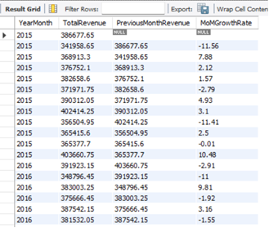
- Calculate the rolling 3-month average revenue for each product category. (SQL)
Query:
WITH MonthlyCategoryRevenue AS (
SELECT
DATE_FORMAT(str_to_date(OrderDate,'%d/%m/%Y'), '%Y-%m') AS YearMonth,
ProductCategory,
SUM(SalePrice) AS TotalRevenue
FROM
orders
GROUP BY
YearMonth, ProductCategory
ORDER BY
YearMonth
)

SELECT
mcr.YearMonth,
mcr.ProductCategory,
mcr.TotalRevenue,
AVG(mcr.TotalRevenue) OVER (
PARTITION BY mcr.ProductCategory
ORDER BY mcr.YearMonth
ROWS 2 PRECEDING
) AS Rolling3MonthAvgRevenue
FROM
MonthlyCategoryRevenue mcr
ORDER BY
mcr.ProductCategory, mcr.YearMonth;
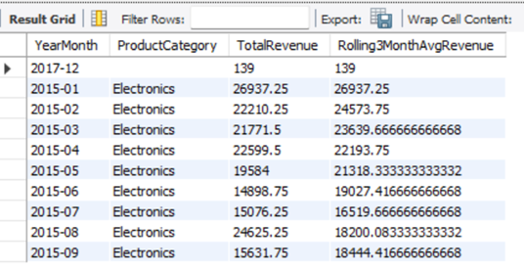

- Update the orders table to apply a 15% discount on the `Sale Price` for orders placed by customers who have made at least 10 orders. (SQL)
Query:
UPDATE orders
SET SalePrice = SalePrice * 0.85
WHERE CustomerID IN (
SELECT CustomerID
FROM orders
GROUP BY CustomerID
HAVING COUNT(OrderID) >= 10
);

- Calculate the average number of days between consecutive orders for customers who have placed at least five orders. (SQL)
Query:
WITH EligibleCustomers AS (
SELECT
CustomerID
FROM
orders
GROUP BY
CustomerID
HAVING
COUNT(OrderID) >= 5
),
OrderIntervals AS (
SELECT
o.CustomerID,
o.OrderDate,
DATEDIFF(o.OrderDate, LAG(o.OrderDate) OVER (
PARTITION BY o.CustomerID ORDER BY o.OrderDate
)) AS DaysBetweenOrders
FROM
orders o
WHERE
o.CustomerID IN (SELECT CustomerID FROM EligibleCustomers)
),
AverageDaysPerCustomer AS (
SELECT
CustomerID,
AVG(DaysBetweenOrders) AS AvgDaysBetweenOrders
FROM
OrderIntervals
WHERE
DaysBetweenOrders IS NOT NULL
GROUP BY
CustomerID
)
SELECT
AVG(AvgDaysBetweenOrders) AS OverallAvgDaysBetweenOrders
FROM
AverageDaysPerCustomer;
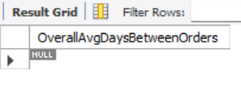
- Identify customers who have generated revenue that is more than 30% higher than the average revenue per customer. (SQL)
Query:
WITH CustomerRevenue AS (
SELECT
CustomerID,
SUM(SalePrice) AS TotalRevenue
FROM
orders
GROUP BY
CustomerID
),
AverageRevenue AS (
SELECT
AVG(TotalRevenue) AS AvgRevenue
FROM
CustomerRevenue
)
SELECT
cr.CustomerID,
ROUND(cr.TotalRevenue,2) AS TotalRevenue,
ROUND(ar.AvgRevenue,2) AS AvgRevenue,
ROUND((cr.TotalRevenue - ar.AvgRevenue),2) AS ExcessRevenue
FROM
CustomerRevenue cr
CROSS JOIN
AverageRevenue ar
WHERE
cr.TotalRevenue > ar.AvgRevenue * 1.3
ORDER BY
cr.TotalRevenue DESC;
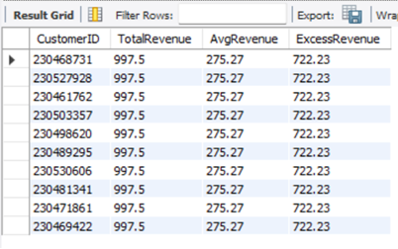

- Determine the top 3 product categories that have shown the highest increase in sales over the past year compared to the previous year. (SQL)
Query:
WITH YearlyCategorySales AS (
SELECT
DATE_FORMAT(str_to_date(OrderDate,'%d/%m/%Y'), '%Y') AS SalesYear,
ProductCategory,
SUM(SalePrice) AS TotalSales
FROM
orders
GROUP BY
SalesYear, ProductCategory
),
CategorySalesGrowth AS (
SELECT
ycs.ProductCategory,
ycs.SalesYear,
ycs.TotalSales,
LAG(ycs.TotalSales) OVER (PARTITION BY ycs.ProductCategory ORDER BY ycs.SalesYear) AS PreviousYearSales,
(ycs.TotalSales - LAG(ycs.TotalSales) OVER (PARTITION BY ycs.ProductCategory ORDER BY ycs.SalesYear)) AS SalesIncrease
FROM
YearlyCategorySales ycs
),
RankedCategories AS (
SELECT
csg.ProductCategory,
csg.SalesYear,
csg.TotalSales,
csg.PreviousYearSales,
csg.SalesIncrease,
DENSE_RANK() OVER (ORDER BY csg.SalesIncrease DESC) AS `Rank`
FROM
CategorySalesGrowth csg
WHERE
csg.SalesYear = (SELECT MAX(SalesYear) FROM orders)
)
SELECT
ProductCategory,
SalesYear,
ROUND(TotalSales,2) AS TotalSales,
ROUND(PreviousYearSales,2) AS PreviousYearSales,
ROUND(SalesIncrease,2) AS SalesIncrease
FROM
RankedCategories
WHERE
`Rank` <= 3
ORDER BY
SalesIncrease DESC;
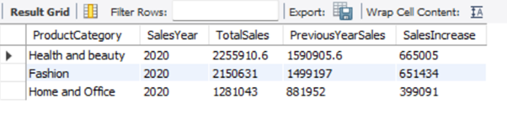

Subjective Questions:
- Explain the revenue breakdown by year and by-product. Evaluate how different products contribute to annual revenue and come up with suggestions to increase the sales of the low-selling items.
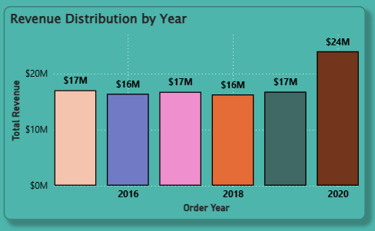
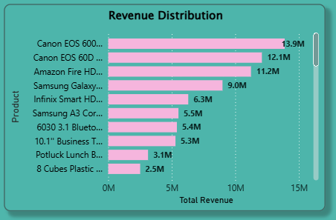

- In the first column chart, we can see how revenue break down by each year. In the second column chart, it is noticeable how different products contribute to annual.
- To increase the sales of low-selling items we can use some strategies like Selling in a bundle of low-priced items to increase their revenue, marketing promotions for low selling items, giving more points on the purchase of that product etc.

- How many products were returned? Use a DAX function to get this metric. Examine the possible reasons for returns and consider how this metric could indicate improvements in product descriptions or quality control.

- The total number of returns is 31K with 44 unique products.
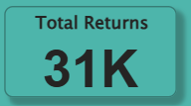
- The possible reasons for the returns are:

- Defective items - Delivering the defective items makes customers lose interest in the quality of the brand. So, make sure before going for a package the quality of the product needs to be checked.

- Delivery Missing item/part - Product description should mention clearly all the components and should provide a checklist of what's included.

- Onsite Description Mismatch - Product description should match with the products that are going to deliver otherwise it leads to customer dissatisfaction. Make sure to regularly update the description in the online platform.

- Product not fitting expectations - Make sure the size chart provided in the product description shows multiple options for customers to choose perfect size.

- Delivery wrong item - Have multiple checkpoints to see if the right product is going for a package before delivering the product.

- Unknown Reasons - There are some unknown reasons for the product to be returned. Make sure while collecting the return packages take note of the reasons for return for better understanding.

- Whenever a customer goes to Amazon, they’ll filter the most rated products to buy the better category. Can you verify this using any visualization or table that the ratings of products impact their sales value?
Insight / Analysis:
- The below line chart illustrates the relationship between product ratings and average sale price.

- It shows that products with higher ratings tend to achieve higher average sales value, confirming that customer ratings positively influence purchasing behavior.

- It is evident that products with lower ratings have higher sales. This could be for several reasons like immediate need of the product, low price of the product, availability of the specific product in the platform, specific brand etc.
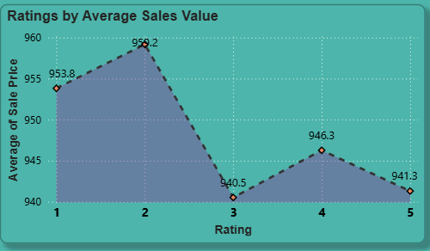
- From the visualization, it can be observed that the average sale price tends to increase for products with higher ratings (especially between 2 to 4 stars).

- This pattern indicates that customers are more likely to spend on products that have better ratings, reflecting the influence of customer satisfaction and trust on sales performance.

- However, a slight drop at the 5-star level might suggest limited products or overpricing in that range.
Recommendations:
- Highlight high-rated products (4 stars & above) in product listings to attract more customers.
- Encourage more reviews — better feedback visibility helps increase sales confidence.
- Investigate low-rated products to identify issues in quality or service.
- Use rating-based promotions, such as “Top Rated Products” campaigns, to enhance customer engagement.

- Investigate how revenue distribution varies across different locations. Explore which geographical areas contribute most to sales and consider the strategic implications for regional marketing and distribution efforts. How might location-based trends inform the company's market segmentation and resource allocation approach?
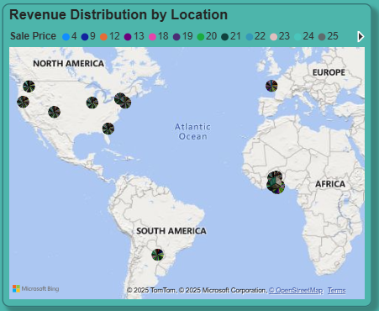
- From the above Map chart, we can see the revenue distribution across different locations. As we can see North America and African regions contribute most to sales, so tailor the marketing strategies accordingly. For example, North American regions, based on the regional demands adjust the product categories and price to meet the demands. As for distribution, collaborate with regional delivery partners to accommodate smooth delivery. Regional marketing should involve the traditions of that particular region so that it affects the sentiment of the customers and it attracts more customers.
- Location based trends help the company to identify key locations where they can focus more on marketing promotions as they can generate more revenue compared to other locations. Company can also increase distribution channels and establish more warehouses for fast delivery of the products.
- Determine which month could benefit from enhanced promotional offers to boost sales. Can you suggest some targeted marketing strategies here?
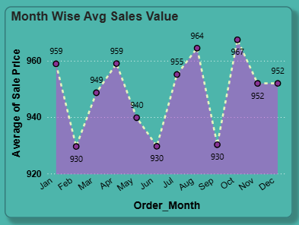
- From the aboveArea chart, we can see the Month wise sales in the company. As we observe the chart February, June and September sales are slightly less compared to other months. From enhanced promotional offers these months could benefit to boost sales.
- Targeted marketing strategies like Time limited sales, special discounts and incentives on that particular month could increase the sales. Go for more advertising on that particular month with the special deals.

- Identify which products may require increased marketing efforts. Which items have high prices yet underperform in sales?

Analysis:
To identify underperforming products, I created three DAX measures in Power BI:
- Total Sales: Total_Sales = SUM(Orders[SalePrice])
- Average Price: Avg_Price = AVERAGE(Orders[UnitPrice])
- Sales-to-Price Ratio: Sales_to_Price_Ratio = DIVIDE([Total_Sales], [Avg_Price])
- A Stacked Bar Chart visual was used, displaying Product on the Y-axis and Sales-to-Price Ratio on the X-axis.
A Bottom 5 filter was applied based on this ratio to highlight products that have a high price but low sales performance.

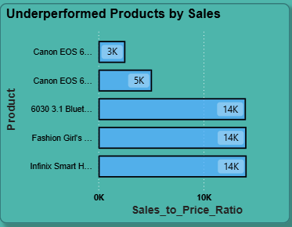

Insights:
- Products such as Cannon DSLR, Bluetooth Home Theater, Yazole Leather Watch, and Luxury Handbag Set show higher pricing but comparatively lower total sales.
- These products are likely perceived as premium, yet they fail to attract enough buyers, suggesting a gap between pricing strategy and customer interest.
- The Sales-to-Price Ratio effectively identified items generating less revenue relative to their price point.
Recommendations:
- Implement targeted marketing campaigns focusing on these premium-priced items to improve visibility.
- Offer limited-time discounts or bundle offers to make high-priced products more appealing.
- Enhance product descriptions, imagery, and reviews to better communicate value to customers.
- Conduct a competitor price comparison to ensure pricing aligns with market expectations.
- Assess which products should have discounts. How can targeted incentives drive sales and customer loyalty for specific products?
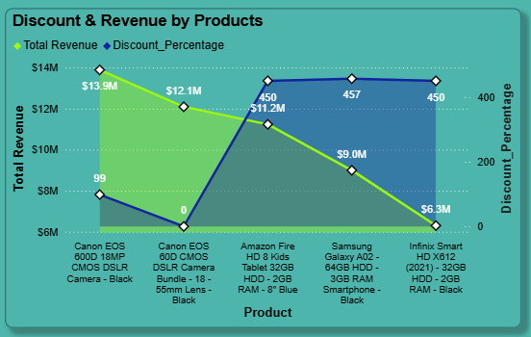
Analysis / Insights:
- The Area chart illustrates both Total Revenue and Discount Percentage for top-performing products.
- Products like Canon EOS cameras and Amazon Fire Tablets show high revenue despite moderate discount percentages, indicating strong market demand even without heavy discounts.
- Conversely, items like Infinix Smart HD and Samsung Galaxy models show lower revenue levels, even with comparable or higher discounts.
- This pattern suggests that not all products benefit equally from discounts — some rely more on brand value and customer preference.
Recommendations:
- Increase discounts on low-revenue, price-sensitive products such as budget smartphones and accessories to stimulate demand.
- For high-revenue items, maintain moderate discounts to protect margins while sustaining customer interest.
- Implement targeted promotional offers (e.g., limited-time bundles or festival discounts) on underperforming categories to drive sales and build customer loyalty.
- Continuously monitor revenue vs. discount effectiveness to adjust pricing strategies dynamically.
- Come up with a loyalty program to benefit the company’s customers. From the available lot of customers come up with strategies to bucket them and provide benefits under different loyalty programs.
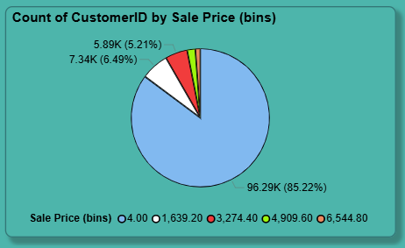
Analysis / Insights:
- As shown in the above chart, customers are grouped into five categories based on their spending capacity.
- The majority of customers (~85%) belong to the lowest spending segment, while a small percentage represent high-end buyers.
- This insight helps in designing tiered loyalty programs that align with customer behavior and maximize satisfaction across all segments.
Recommendations:
- Introduce a tiered loyalty program with Bronze, Silver, Gold, Platinum, and VIP levels tied to spending ranges.
- Reward repeat buyers with points, exclusive vouchers, or early sale access to strengthen retention.
- Personalize offers — higher discounts or free delivery for lower-spending groups to push them to the next tier.
- Monitor customer transitions across segments regularly in Power BI to measure loyalty program success.
- Leverage communication channels like emails or app notifications to promote tier-based benefits and seasonal rewards.
- Using the DAX functions Calculate and a row iteration DAX function calculate the total sales for the Product Category “Fashion” and delivery type “Shipped from Abroad”. What are the other types of DAX functions you have used in the project?
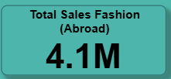
Using CALCULATE and Row Iteration DAX Functions:
- To calculate the total sales for Product Category = “Fashion” and Delivery Type = “Shipped from Abroad” using CALCULATE() and an iterator (SUMX()), and to compare it with other delivery methods for contextual analysis.
- DAX Measure Used:
TotalSales_Fashion_Abroad =
CALCULATE(
SUMX(Orders, Orders[Sale Price]),
Orders[Product Category] = "Fashion",
Orders[Delivery Type] = "Shipped from Abroad"
)
- Apart from CALCULATE() and SUMX(), several other DAX function categories were used throughout the project:
- Aggregation Functions: SUM, AVERAGE, COUNT
- Filter Functions: FILTER, ALL
- Time Intelligence Functions: DATEADD, TOTALYTD, SAMEPERIODLASTYEAR
- Logical Functions: IF, AND
- Mathematical Functions: DIVIDE, ABS
- Statistical Functions: RANKX
- Iterative Functions: SUMX, AVERAGEX
- Information Functions: ISBLANK
- Wait Times Correlated with Demographics and Care: Explore how average wait times vary across different product categories to optimize scheduling and staffing.

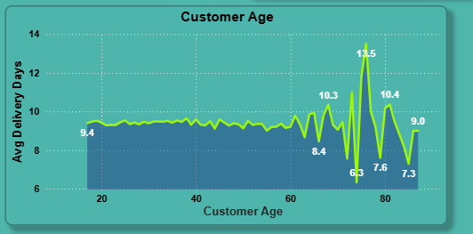
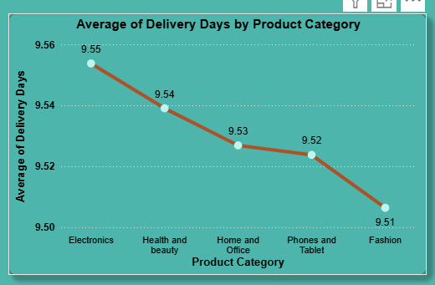

- Here Wait Time means Delivery Time from my dataset. In the first Line chart, we can see how wait time correlate with demographic i.e. Customer age. In the graph, above 60 years age group the average delivery time varies from 8.34 days to 13.50 days. Below 60 years there is no much variation in the average delivery time.

- In the second Line chart, we can see how average wait time vary across different product categories. For “Phones and Tablet” the average delivery time is 9.455 which is more compared to other product categories. We can do the scheduling and staffing accordingly.
- Explore if there is any relationship between the Delivery type and waiting time between ordering and receiving an item.
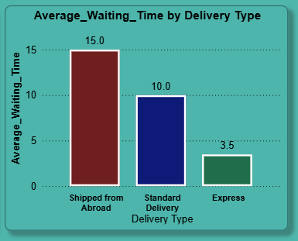

- As we can see in the above Line chart, there are mainly 3 different delivery types. Each delivery type has a different delivery time. Express delivery has an average of 3.49 days. Standard delivery type has an average of 10 days to deliver the product. Products from abroad will take more days to deliver.
- Is there any relationship between shipping charges and product type?
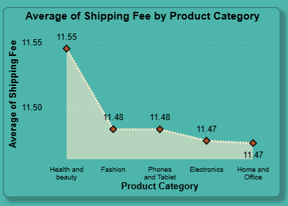
- By using Area chart with Product Category in X-axis and Average of Shipping fee in Y-axis, we can see the relationship between Shipping fee and product category. As we can see in the chart, Health and Beauty have high average shipping fee.
- Come up with strategies to decrease the low rating orders after analyzing different factors like waiting time, shipping type, unit price, etc.
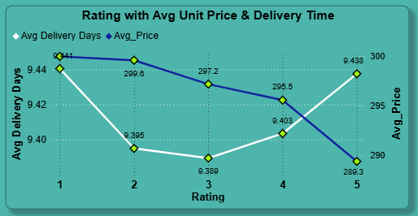

- To come up with different strategies to decrease the low rating orders, I have analyzed the waiting time, unit price for each rating.
- Here I used Line chart to display the waiting time and unit price for each rating.
- In the above chart, we can see for 5 rating the average delivery time and average unit price is low compared to other ratings.

Strategies to decrease low rating orders:
- We can decrease the low rating orders by decreasing the delivery time. This can be done by offering them different delivery options like Express delivery, Standard delivery etc.
- By lowering the unit price, low rating orders can also be reduced.
- Using the time intelligence DAX function, create a table to compare each month’s sales with the previous year’s same month’s total sales. So there will be four columns in the output year, month, total sales, previous_years_sales.
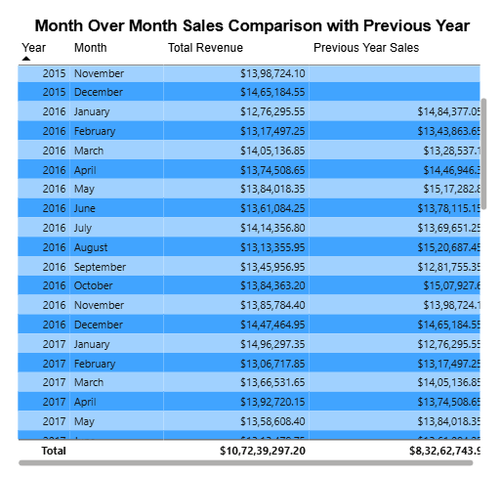
- Objective: Shows month-over-month comparisons to identify trends and growth.
- Year and Month Columns: Displays the year and month of sales data.
- Total Sales: Represents the total revenue generated for each month.
- Previous Year's Sales: Compares the same month's sales from the previous year.
- This helps analyze sales performance and year-over-year changes.

- What do you understand by PowerBI gateway? What are its use cases?

- Power BI Gateway: A Power BI Gateway is a bridge that facilitates secure data transfer between on-premises data sources and Microsoft cloud services, such as Power BI, Power Apps, Power Automate, and Azure Logic Apps. It allows organizations to connect their local (on-premises) data to Power BI reports and dashboards in the cloud without moving the data.

- Use Cases of Power BI Gateway:

- Data Refresh: Automatically refresh on-premises data in Power BI.
- Live Query: Query on-premises data in real-time.
- Hybrid Scenarios: Connect cloud and on-premises data sources.
- Secure Access: Encrypt data transfer for security compliance.
- Integration: Link with Power Apps, Power Automate, and Azure Logic Apps.
- Multi-Source Support: Connect to various on-premises data sources (SQL Server, Oracle, etc.).

- How would you approach this problem, if the objective and subjective questions weren't given?

To approach the problem without predefined questions, I would:
- Understand Data Structure: Analyze tables (customers, orders), relationships, and key metrics.
- Data Cleaning: Handle missing values, correct data types, and remove duplicates.
- Data Modeling: Create relationships, design key DAX measures (e.g., total sales, revenue growth).
- Analyze Insights: Segment customers, analyze product/category performance, and revenue distribution.
- Visualize Data: Create dashboards for sales, customer insights, and product performance.
- Scenario Analysis: Identify low-performing products, suggest promotional strategies, and design loyalty programs.
- Reporting: Generate reports with actionable insights and strategic recommendations for improving sales and customer engagement.

